Phase III: Data Modeling and Relationships
Admissions & Academic Journey CRM
Custom Objects
Explanation: The project leverages a hybrid model, using standard Salesforce objects for basic functions and custom objects to model the unique student lifecycle from inquiry to graduation.
Salesforce Path: Setup > Object Manager > Custom object Custom Objects Created:
- Prospective Student: To track individuals who have shown interest before they formally apply.
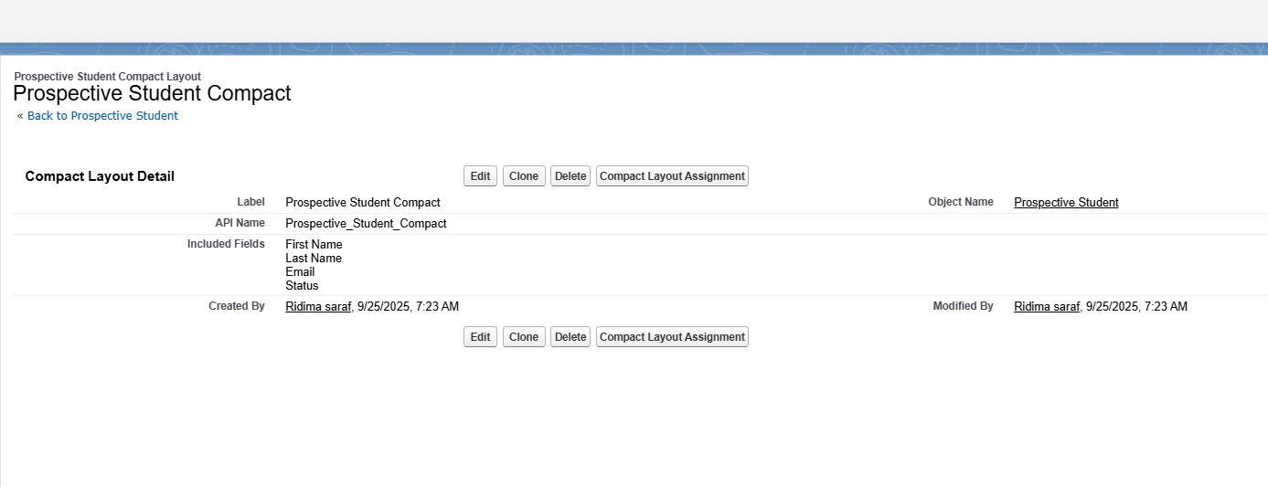

- Application: To manage the entire application process from submission to the final decision.
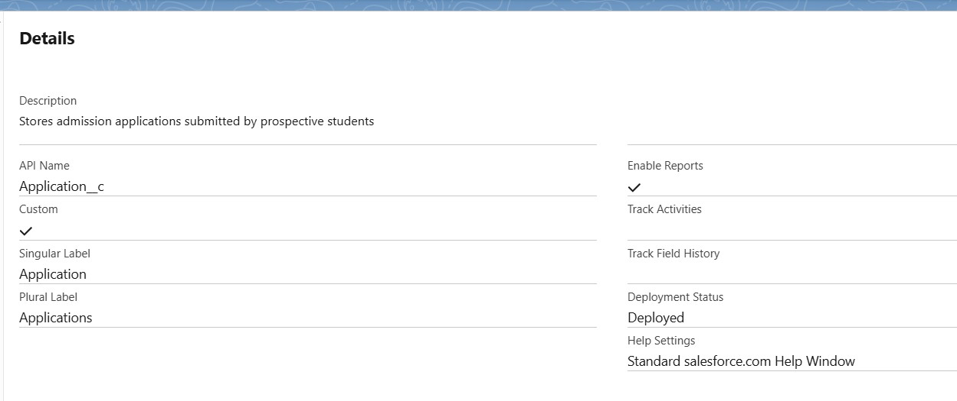

- Student: To hold the official and central record of an enrolled student throughout their academic career.
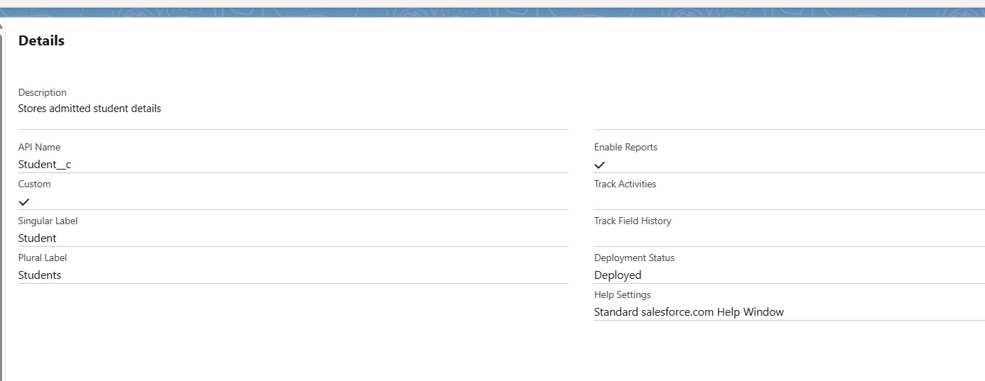

- Academic Record: To track the grades, credits, and academic performance of a student for each course or term.
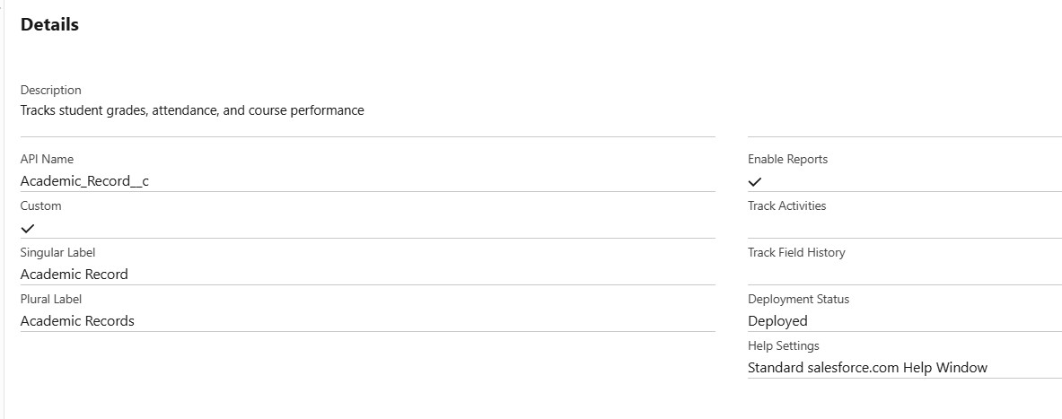
- Course: To store a catalog of all individual courses the university offers.
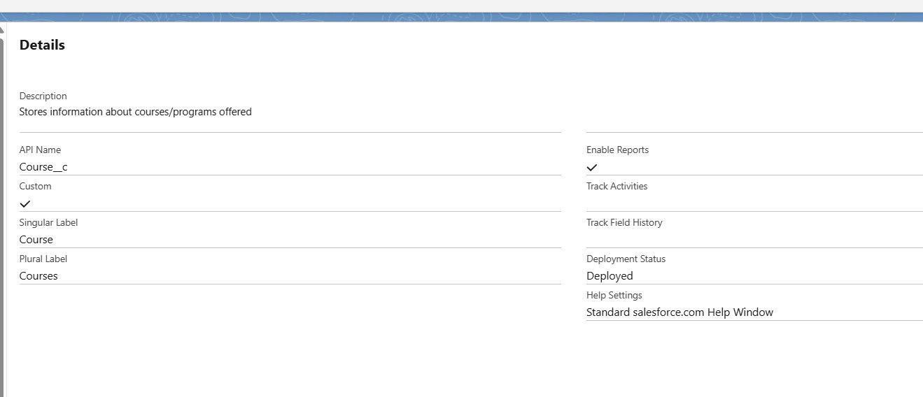
- Department: To organize the university's different academic areas.
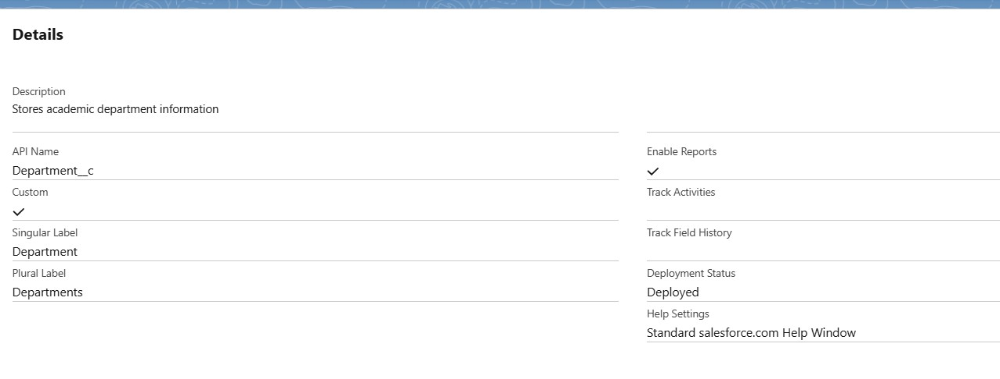
- Counseling Note: To log all interactions and meeting notes between academic advisors and students.
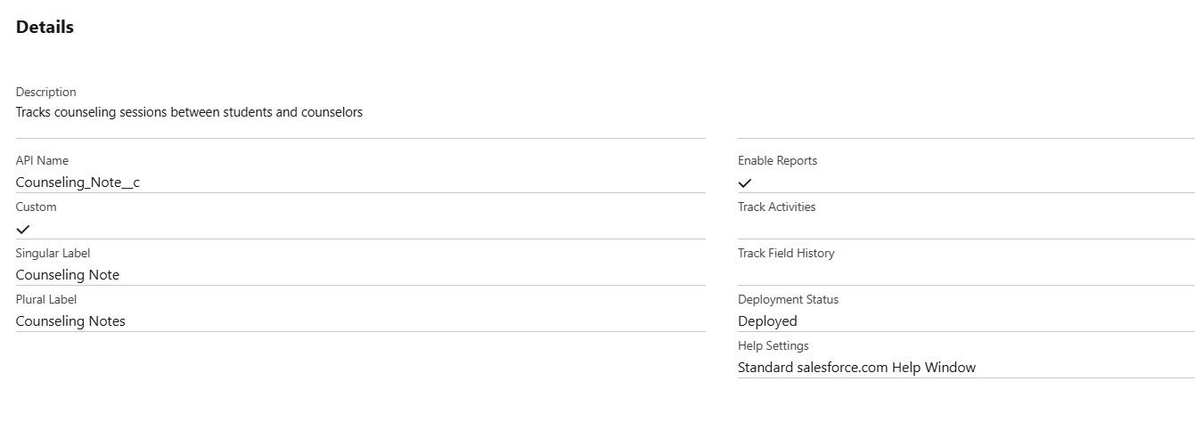

Fields & Relationships
Explanation: Custom fields were created for each object to capture specific data points for admissions and academic tracking, and relationships were built to connect these objects into a logical data model.
Salesforce Path: Setup > Object Manager > Select Object >
Fields & Relationships

Procedure & Configuration:
- Prospective Student: Field present in it .
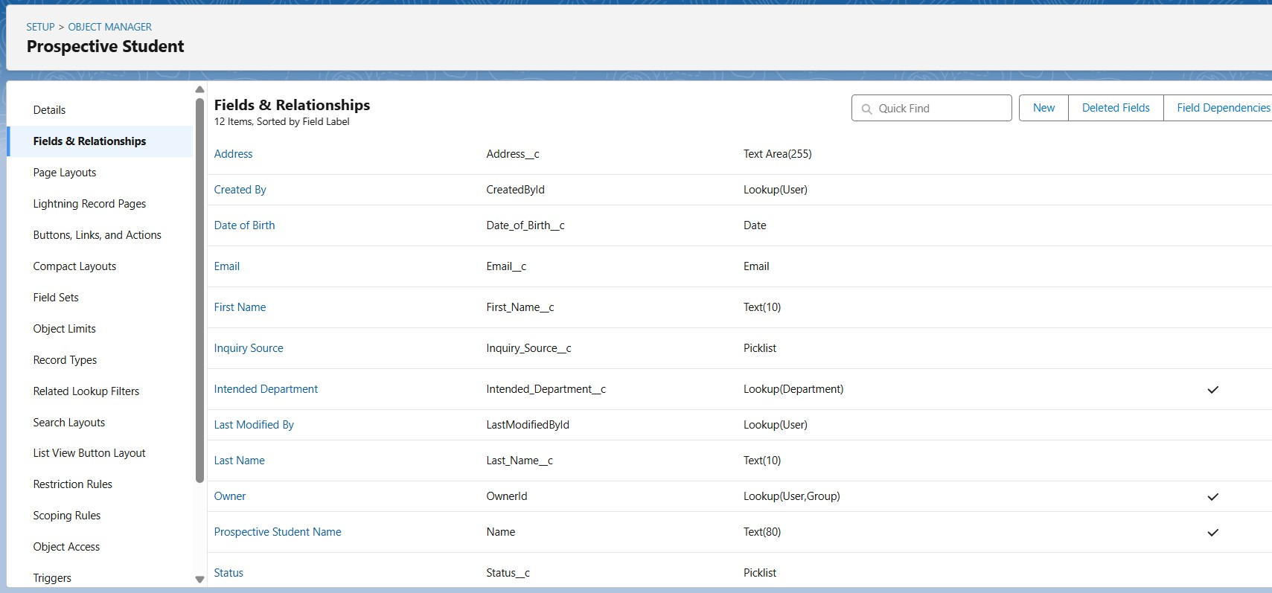
- Application: Field present in it .
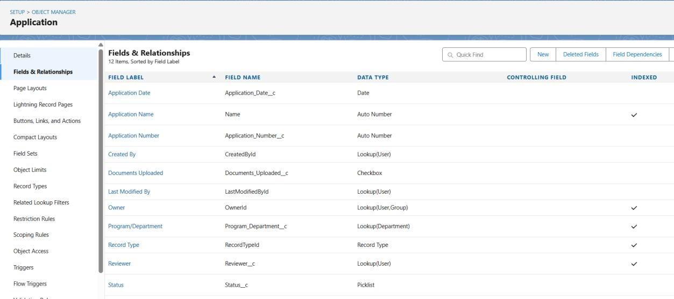
- Student: Field present in it.
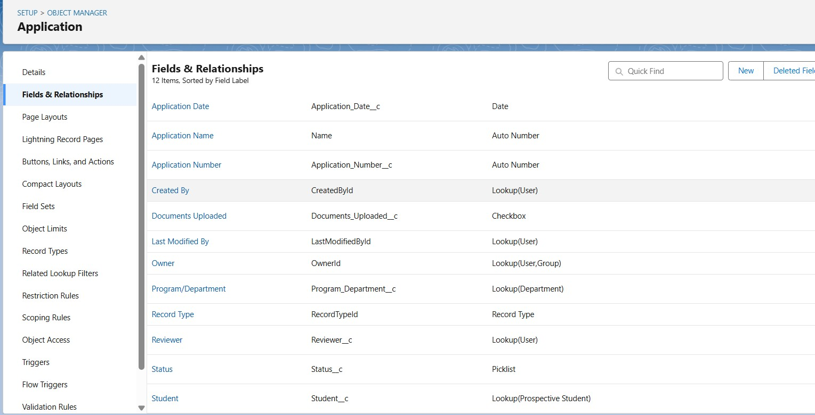
- Course: Field present in it.
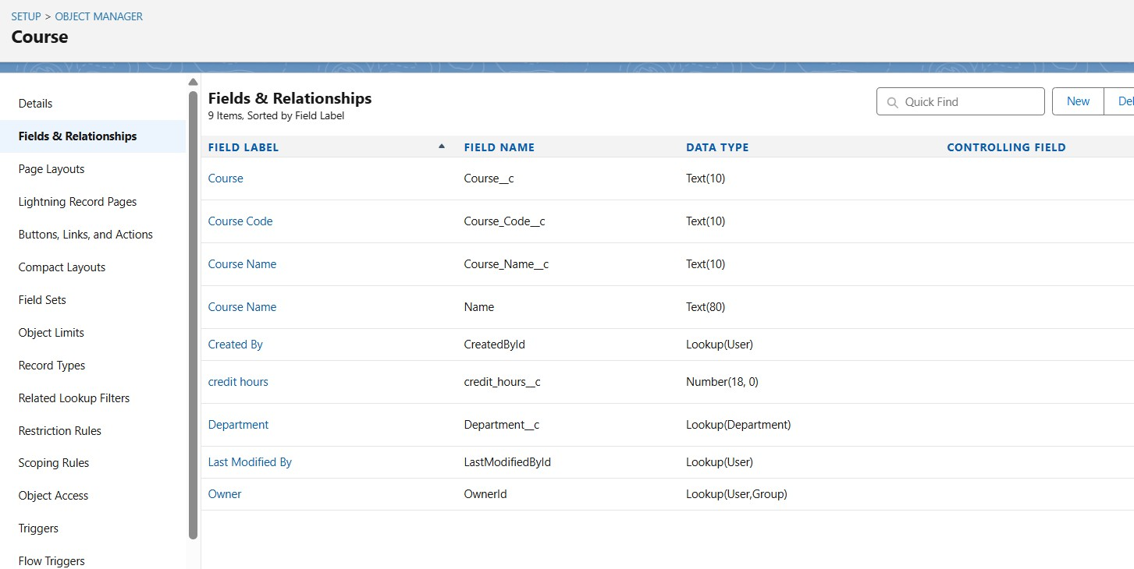

- Academic Record: Field present in it.
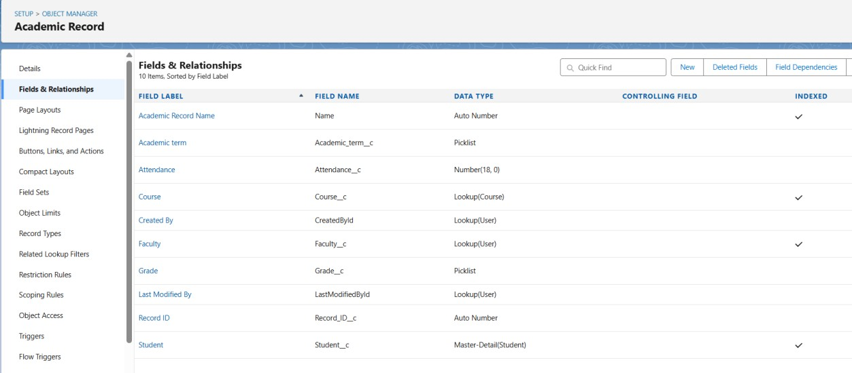
Key Fields in Academic Record:
• Attendance: Stores attendance percentage.
• Grade: Stores student grade for the course.
• Course: Lookup to Course object.
• Student: Lookup to Student object.
Department: Field present in it.
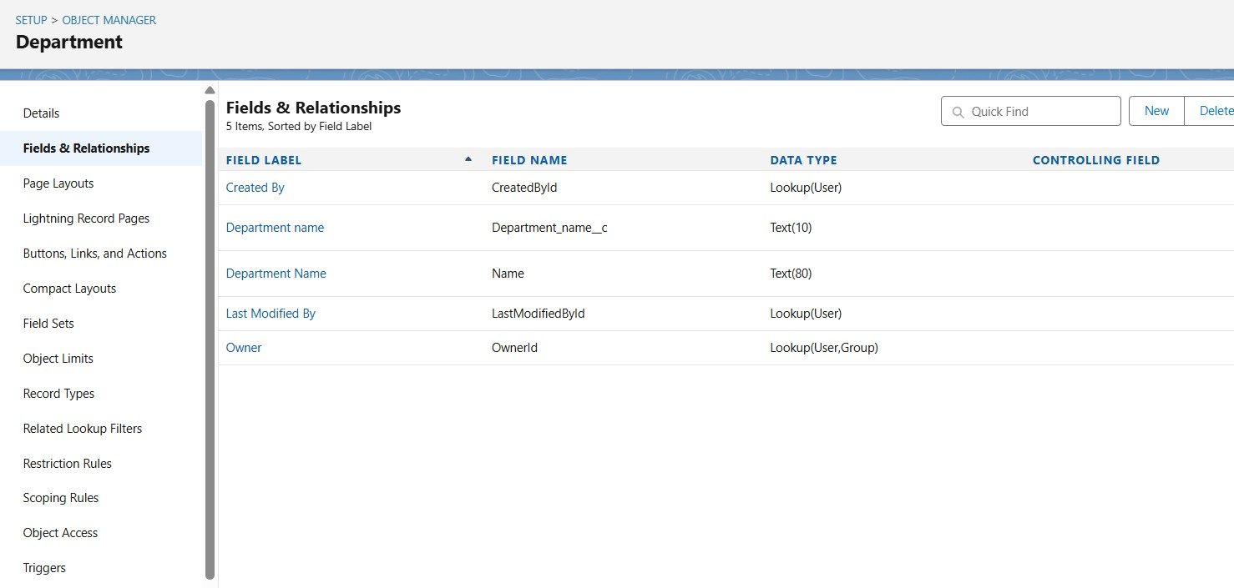

Record Types & Page Layouts
Explanation: Record types and page layouts were configured to provide a tailored user experience based on the academic level (Undergraduate vs. Postgraduate). Compact layouts were set up to provide a quick summary of key information on each record.
Salesforce Path: Setup > Object Manager > Select Object >
Record Types and Page Layouts Procedure & Configuration:
- Record Types: Two record types were created for the Application object: UG and PG.
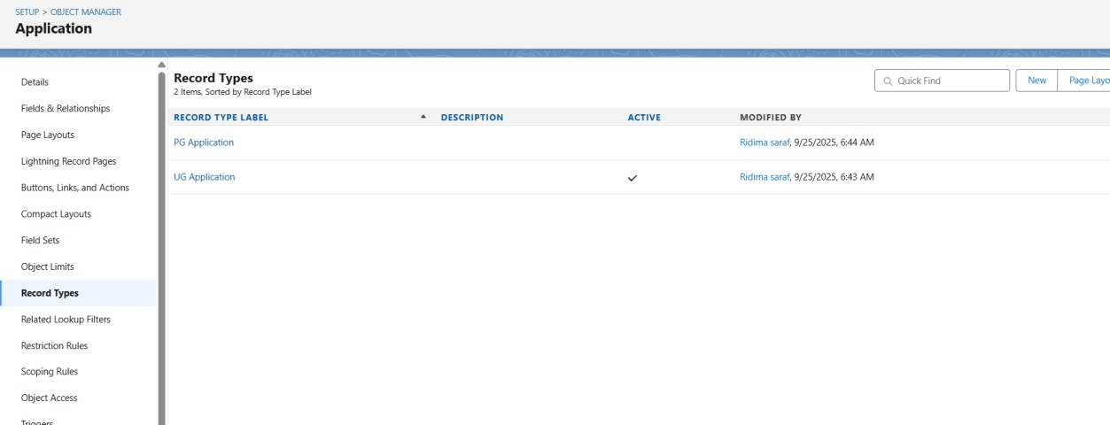
- Page Layouts:
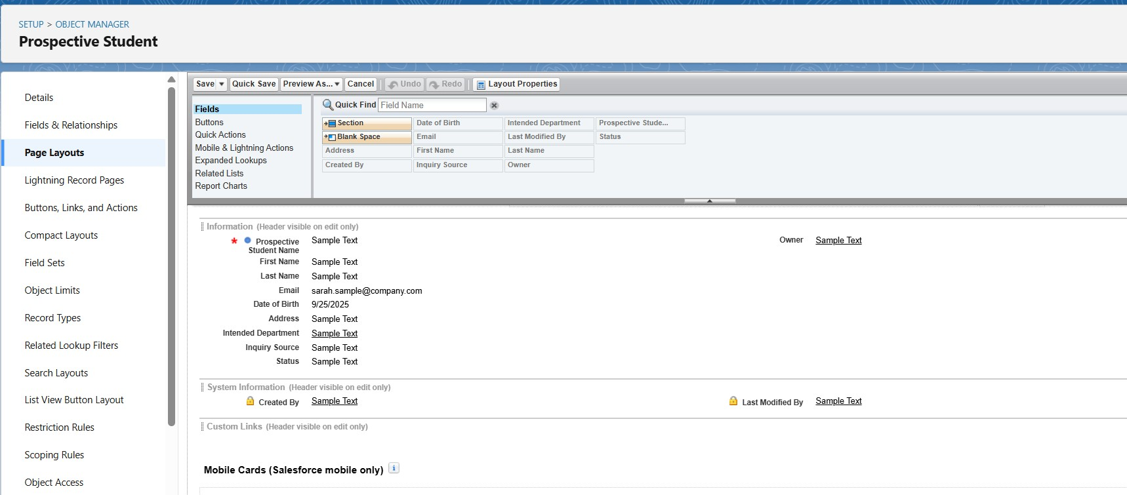

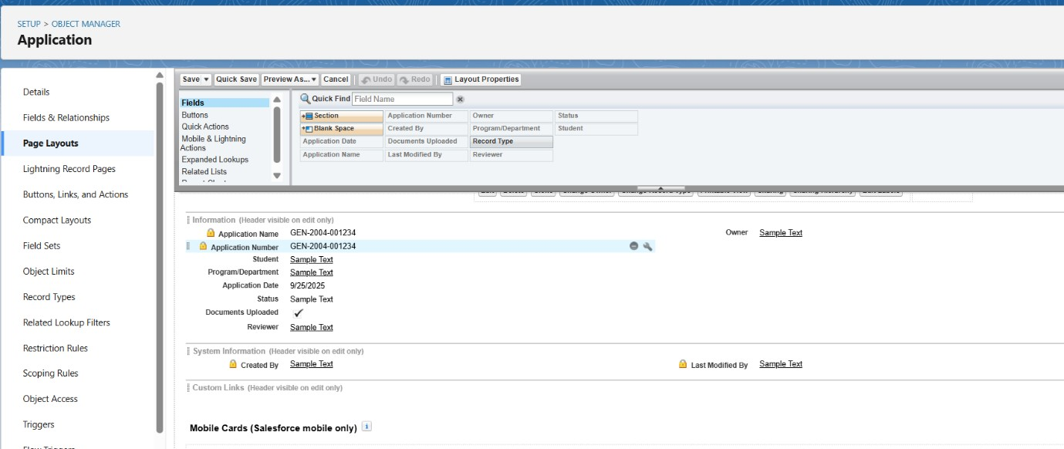

Compact Layouts
The primary compact layout was configured for key objects like Student and Application to ensure important fields are visible in the highlights panel.
“An Academic Record compact layout was added to display course, term, grade, and attendance at a glance.”
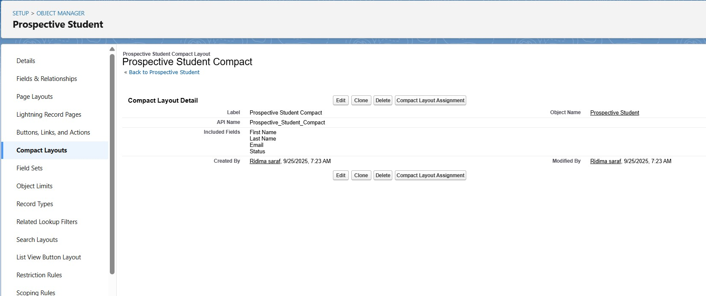

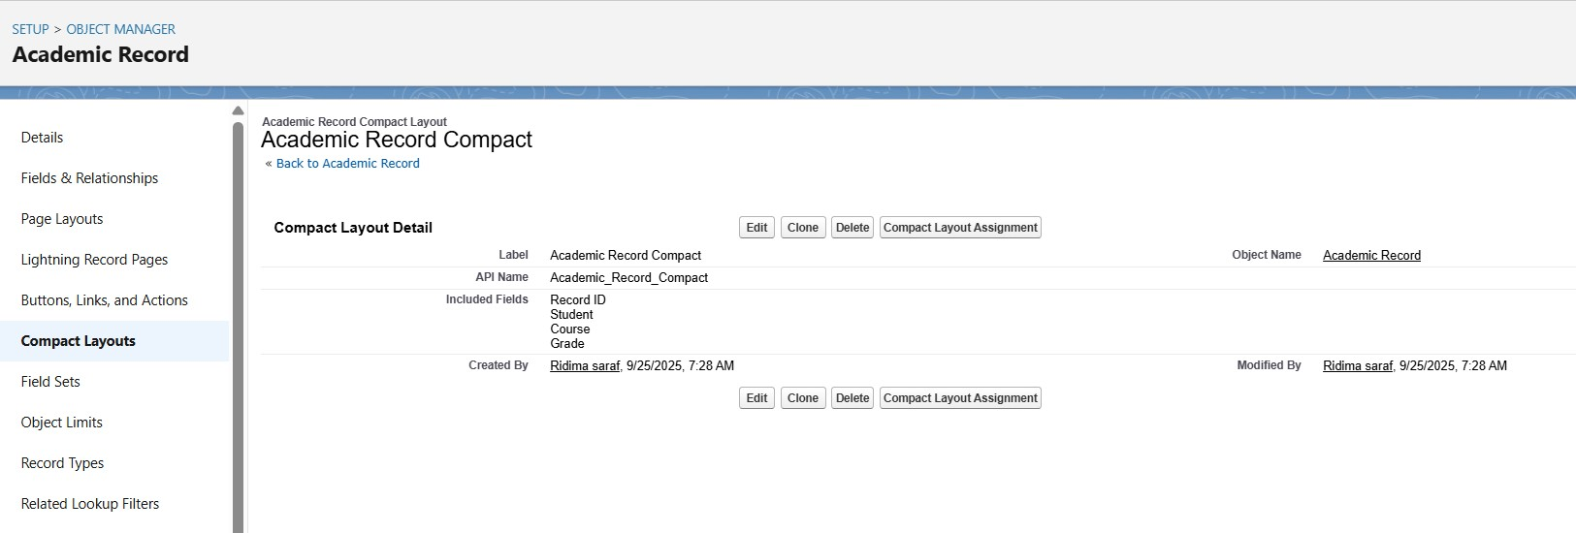

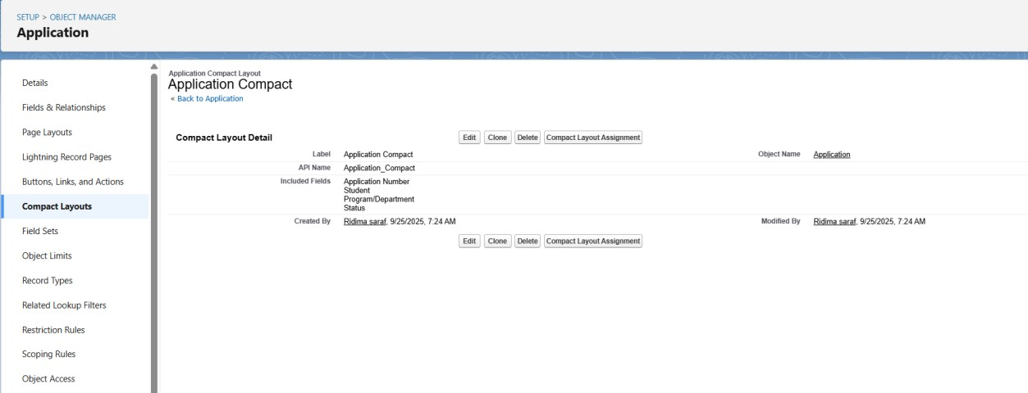

Lookup vs Master-Detail Relationship

Lookup Relationship
A loose link between two objects. The child record can exist without the parent. Deletion of the parent does not delete the child.
“In this project, all relationships (Student–Academic Record, Course–Academic Record, Prospective Student–Application) use Lookup Relationships, as they provide more flexibility.”

Master-Detail Relationship
A tight link where the child record is controlled by the parent. The child cannot exist without the parent, and deleting the parent deletes the child. Also supports roll-up summary fields.

